2 – 1. Piecewise Defined Functions – Practice Set 1
1. [C] This is not a well-defined piecewise defined function. Why not?
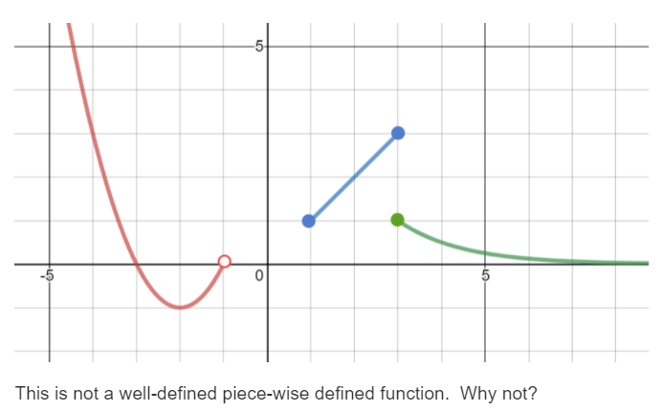

2. [P] Consider $f\left(x\right)=\left\{\begin{aligned}\frac{-1}{x}, x<0 \\ -\frac{1}{2}x, 0≤x<4 \\ \sqrt{x}-2, 4≤x\end{aligned}\right.$
(a). Evaluate: $f\left(9\right)=$ ______ (b). Evaluate: $f\left(f\left(f\left(-3\right)\right)\right)=$ ______

3). [P] Write a piece-wise defined function for each graph. [ id what basic family; figure out what transformations to apply… ]
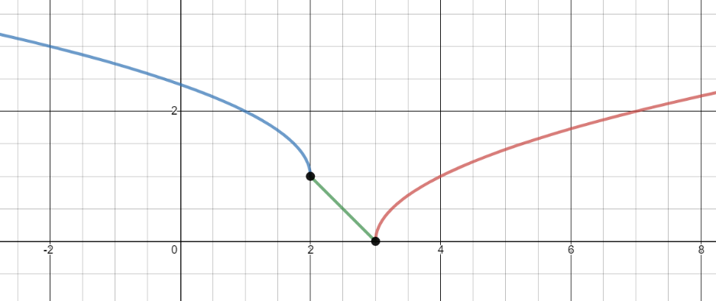
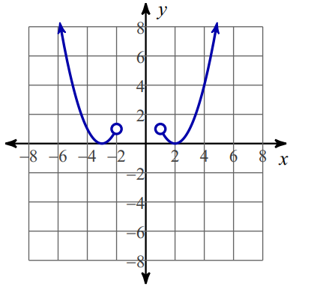
A. B.

4). [P] The Geckofactor on-line store has the following shipping charges. When the weight of your total order is 5 lbs or less, there is a flat charge of $10. If it exceeds 5 lbs but does not exceed 10lbs, each additional lb is $1.5 /lb. If the weight is 10 lbs or more, the charge drops to $0.80 /lb.
a. Write a rule for the piecewise-defined function D(x) which represents the total shipping fee vs the weight x.
b. What is the maximum weight of your order if you don't want to pay more than $20 for the shipping fee? (Briefly!) Explain your reasoning.

5). [P] Sketch your own graph of each piece-wise defined function.
Do not make an entire table of values!
Identify the basic family. Sketch its shape. Sketch the shape with a transformation applied. THEN finalize your graph. If you want to it’s ok to plug in a point right at the boundaries, but no more than that.

- $f\left(x\right)=\left\{\begin{aligned}{\left(x-2\right)}^{2}-1, x<2 \\ 2^{x-2}, x≥3\end{aligned}\right.$

[ be sure to indicate any asymptotes in your graph ]

- $g\left(x\right)=\left\{ \begin{aligned}3^{x}+1, x≤0 \\ \frac{1}{x}+1, 0<x≤1 \\ -x^{2}-1, 1<x \end{aligned}\right.$

[ be sure to indicate any asymptotes in your graph]

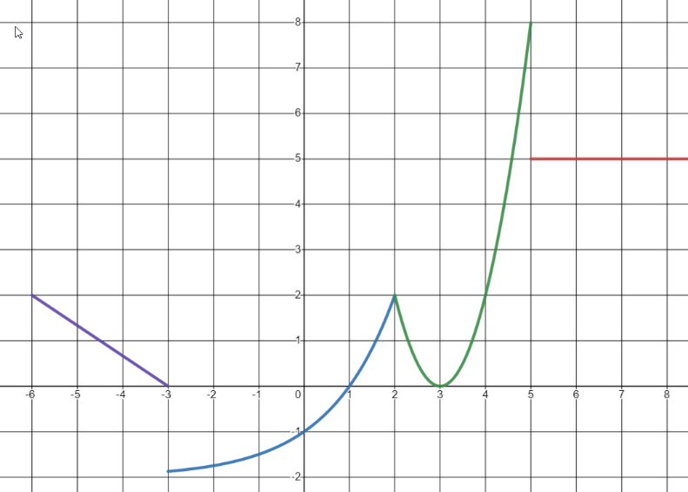
6. [P] This is the graph of a piece-wise defined function with 4 pieces: a linear one, an exponential one, a quadratic one, and a constant one.
a). Write JUST the equation for each piece of the graph above:
Linear:
Exponential:
Quadratic:
Constant:
b). Now combine those pieces together into a piece-wise defined function.

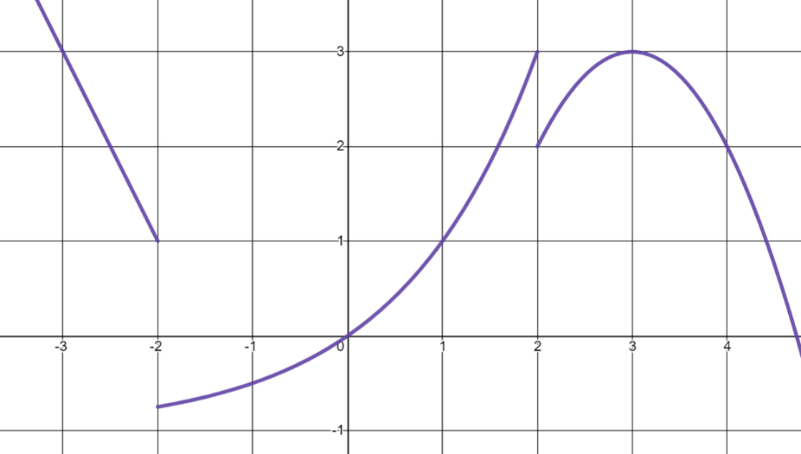
7). [P] Write the function definition for this piece-wise function. Be sure to use correct function notation with domain intervals.

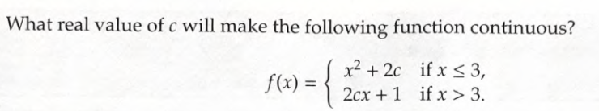
8). [C/P] What real value for c will make this function continuous?

Note: The graph of a continuous function if it has no breaks. In other words, the two “pieces” of the graph have to meet.

9). [P] Lots of practice graphing.
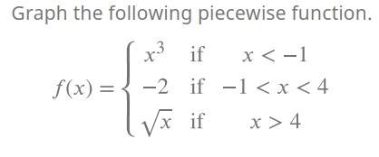

2 – 1. Piecewise Defined Functions – Practice Set 1 – Solutions
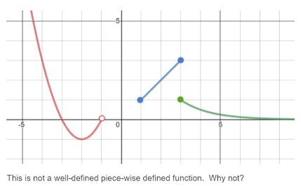
1.
There are two outputs when x = 3, so it can’t be a function.
It’s OK that the function isn’t defined between -1 and 1.

(a). Evaluate: $f\left(9\right)=$ 1

(b). Evaluate: $f\left(f\left(f\left(-3\right)\right)\right)$
$f\left(-3\right)→\frac{1}{3}$ $f\left(\frac{1}{3}\right)→-\frac{1}{6}$ $f\left(-\frac{1}{6}\right)→-\frac{1}{\left(-\frac{1}{6}\right)}=6$

2. Consider $f\left(x\right)=\left\{\begin{aligned}\frac{-1}{x}, x<0 \\ -\frac{1}{2}x, 0≤x<4 \\ \sqrt{x}-2, 4≤x\end{aligned}\right.$

3. Write a piece-wise defined function for each graph. [ id what basic family; figure out what transformations to apply… ]
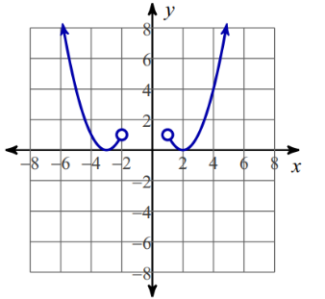
A
- $f\left(x\right)=\left\{\begin{aligned}{\left(x+3\right)}^{2}, x<-2 \\ {\left(x-2\right)}^{2}, x>1\end{aligned}\right.$

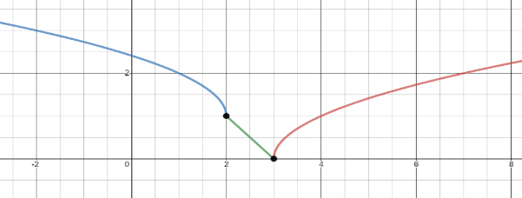
B.
$$g\left(x\right)=\left\{ \begin{aligned}\sqrt{-\left(x-2\right)}+1, x<2 \\ 3-x, 2<x≤3 \\ \sqrt{x-3}, 3<x \end{aligned}\right.$$

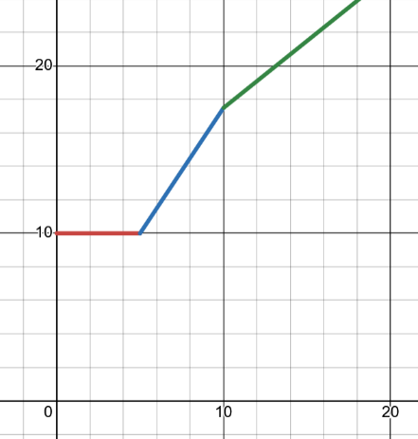
4. The Geckofactor on-line store has the following shipping charges. When the weight of your total order is 5 lbs or less, there is a flat charge of $10. If it exceeds 5 lbs but does not exceed 10lbs, each additional lb is $1.5 /lb. If the weight is 10 lbs or more, the charge drops to $0.80 /lb for every additional pound beyond 10.
  - Write a rule for the piecewise-defined function D(x) which represents the total shipping fee vs the weight x.
$$f\left(x\right)=\left\{ \begin{aligned}10, 0<x≤5 \\ 10+\left(x-5\right)⋅1.5, 5<x≤10 \\ 10+7.5+\left(x-10\right)⋅0.8, 10<x \end{aligned}\right.$$
  - What is the maximum weight of your order if you don't want to pay more than $20 for the shipping fee? (Briefly!) Explain your reasoning.
X has to be larger than 10 for the shipping to exceed $20. We know this because f(10) = 17.5. So using the third equation, we need to solve: $17.5+0.8\left(x-10\right)=20$ $0.8\left(x-10\right)=2.5$ $x-10=3.125$ $x=13.125$
5. Sketch your own graph of each piece-wise defined function Do not make entire tables of values (!!)
Identify the basic family. Sketch its shape. Sketch the shape with a transformation applied. THEN finalize your graph. If you want to it’s ok to plug in a point right at the boundaries, but no more than that.
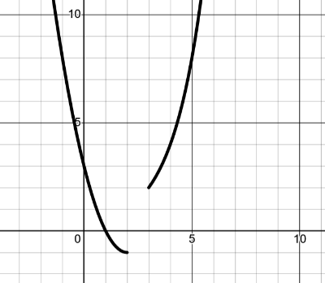
- $f\left(x\right)=\left\{\begin{aligned}{\left(x-2\right)}^{2}-1, x<2 \\ 2^{x-2}, x≥3\end{aligned}\right.$

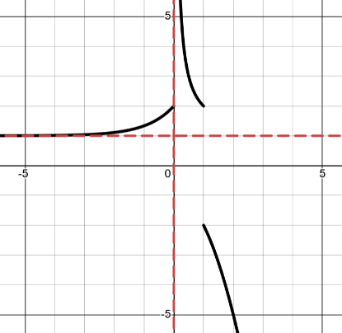
- $g\left(x\right)=\left\{ \begin{aligned}3^{x}+1, x≤0 \\ \frac{1}{x}+1, 0<x≤1 \\ -x^{2}-1, 1<x \end{aligned}\right.$

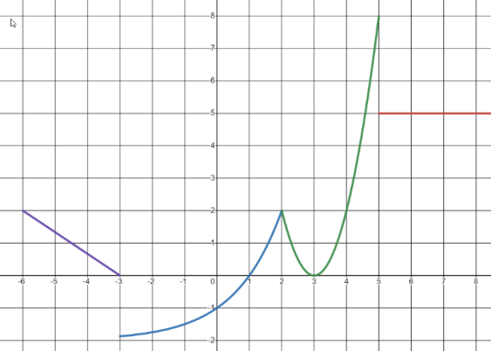
6. This is the graph of a piece-wise defined function with 4 pieces: a linear one, an exponential one, a quadratic one, and a constant one.

$$f\left(x\right)=\left\{{{\begin{matrix}-\frac{2}{3}(x+3) & x < -3\end{matrix} \atop \begin{matrix}2^{x}-2 & -3 < x ≤ 2\end{matrix}} \atop {\begin{matrix}{2⋅\left(x-3\right)}^{2} & 2 < x < 5\end{matrix} \atop \begin{matrix}5 & x ≥ 5\end{matrix}}}\right.$$

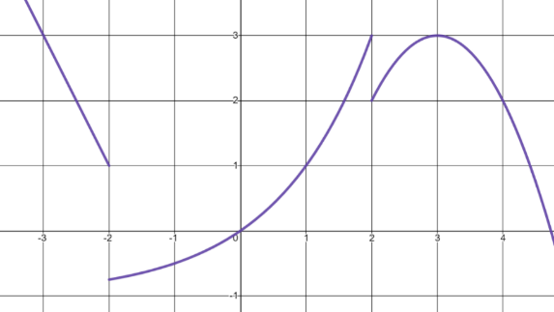
7. Write the function definition for

$g\left(x\right)=\left\{ \begin{aligned}-2\left(x+2\right)+1, x<-2 \\ 2^{x}-1, 0<x<2 \\ {-\left(x-3\right)}^{2}+3, 2≤x \end{aligned}\right.$

8.

A graph is continuous if it has no breaks. In other words, the two “pieces” of the graph have to meet.

If the two pieces have to meet, that means both equations need to have the same y-value when x = 3 (because that’s where they join. Let’s set up an equation: ${\left(3\right)}^{2}+2c=2c\left(3\right)+1$ $2c+9=6c+1$ $8=4c$ $c=2$
9). These ones you can check on desmos =)


